CentRes POS

# **Status Update: Sprint** 3 **– Week** 2

**Submitted by:** S. Andy Short

## **TRELLO BOARD**

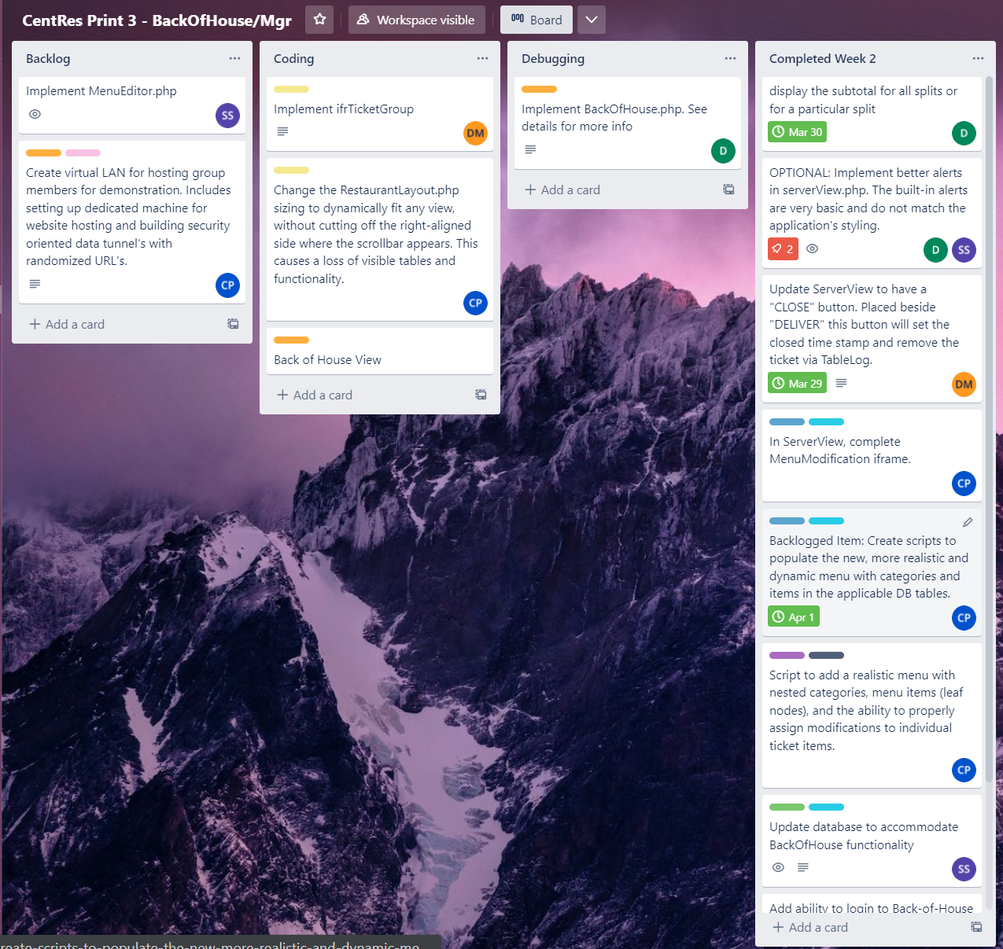

## **STATUS UPDATE DETAILS**

### **Tasks Accomplished**

1. Implemented a bare bones Back of House View to test individual menu frames with.
2. Implemented database connectors for back of house and its associated active ticket group php.

The connectors were designed to have “debug” display features. In production, the connectors will be hidden and running silently in the background.

1. Added subtotal calculation at bottom of ticket in ticket.php
2. Partially implemented the menu modification window. The goal was to make it functional enough to test other components that rely on the data it sends to the db.
3. Modified login screen to handle access to “Back of House”
4. Created a new login process. We have called it “Transient Login.” A temporary account is created to get past sessionLogic.php. That file is responsible for redirected anybody to the login page if not logged in. It also has a restrict access function that reroutes a user to their default view if they are trying to access a privileged page with invalid permissions. Once the temporary account has passed the authorization checks, the temporary account is deleted. We needed this to allow access to the back of house view, while still allowing a manager to stay logged in on another machine, and to allow very restricted privileges to a machine, with multiple people using that device.

### **Problems/Challenges (include status – “resolved/not resolved”)**

1. All buttons are disabled after hiding the mod window in Server View. The user has to select and deselect another ticket item to force button states to update. **STATUS: NOT RESOLVED.** This is a lower priority bug that will be investigated when the workload lessens.

2. Carson pushed a temporary stopgap update to HostView. Some of the restaurant layout was being clipped. His patch has introduced a problem where HostView does not fit on smaller screens. He says the problem has been fixed as well as the original bug. The final solution has not been pushed yet, forcing the status to be **UNRESOLVED This has still not been fixed**

3. Server View would crash after closing the modification window. **RESOLVED. A bad call to a DB procedure with invalid arguments was the culprit.**

4. Lack of specification of communication between coupled pages. Due to ambiguity, the Back of house php and associate active ticket group php were not correctly setting/passing variables between them. **RESOLVED**

5. Lack of standard for modificationNote string. This string has delimiters and is set by the modification window. ticket.php and the active ticket group php both require reading and displaying menu modification items using this. **LOCKED** Development had already started on the active ticket group php. ticket.php has to be recoded to correctly read modificationNote, as the scheme for this string was changed since ticket.php was coded.

5. Severe delays on modification window. As a result of Carson taking too long on developing the modification window (3 weeks), we are now in a position where the menu editor will have to be scrapped. Integration testing will be happening 3 days before the final deliverable should be available to the customer.